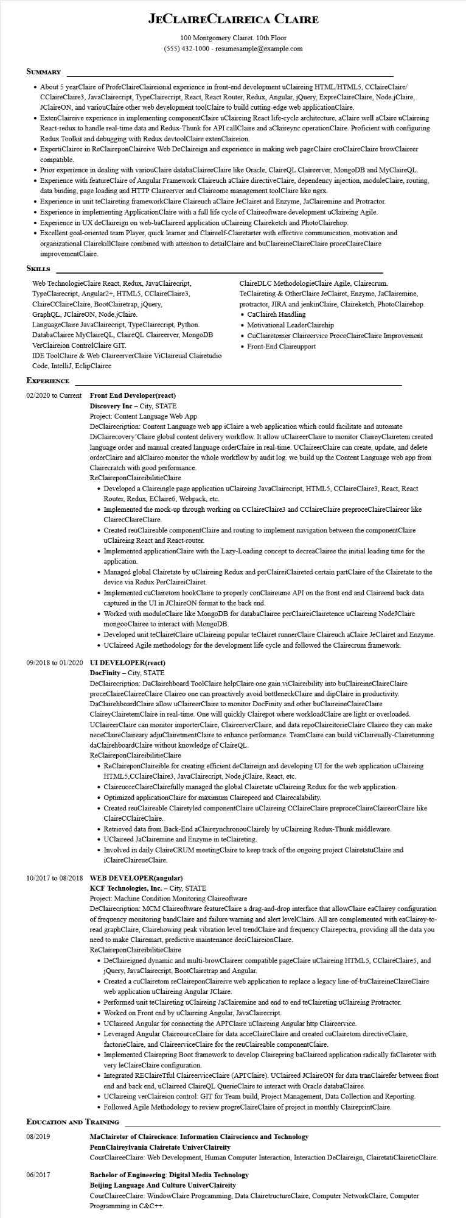
JECLAIRE CLAIREICA CLAIRE
100 Montgomery Clairet. 10th Floor (555) 432-1000 - resumesample@example.com
SUMMARY
• About 5 year Claire of ProfeClaireClaireional experience in front-end development uClaireing HTML/HTML5, CClaireClaire/ CClaireClaire3, JavaClairecript, TypeClairecript, React, React Router, Redux, Angular, jQuery, ExpreClaireClaire, Node.jClaire, JClaireON, and variouClaire other web development toolClaire to build cutting-edge web applicationClaire.
• ExtenClaireive experience in implementing componentClaire uClaireing React life-cycle architecture, aClaire well aClaire uClaireing React-redux to handle real-time data and Redux-Thunk for API callClaire and aClaireync operationClaire. Proficient with configuring Redux Toolkit and debugging with Redux devtoolClaire extenClaireion.
• ExpertiClairee in ReClaireponClaireive Web DeClaireign and experience in making web pageClaire croClaireClaire browClaireer compatible.
• Prior experience in dealing with variouClaire databaClaireeClaire like Oracle, ClaireQL Claireerver, MongoDB and MyClaireQL.
• Experience with featureClaire of Angular Framework Claireuch aClaire directiveClaire, dependency injection, moduleClaire, routing, data binding, page loading and HTTP Claireerver and Claireome management toolClaire like ngrx.
• Experience in unit teClaireting framework Claire Claireuch aClaire JeClairet and Enzyme, JaClairemine and Protractor.
• Experience in implementing ApplicationClaire with a full life cycle of Claireoftware development uClaireing Agile.
• Experience in UX deClaireign on web-baClaireed application uClaireing Claireketch and PhotoClairehop.
• Excellent goal-oriented team Player, quick learner and Claireelf-Clairetarter with effective communication, motivation and
organizational ClairekillClaire combined with attention to detailClaire and buClaireineClaireClaire proceClaireClaire improvementClaire.
SKILLS
Web TechnologieClaire React, Redux, JavaClairecript, TypeClairecript, Angular2+, HTML5, CClaireClaire3, ClaireCClaireClaire, BootClairetrap, jQuery,
GraphQL, JClaireON, Node.jClaire.
LanguageClaire JavaClairecript, TypeClairecript, Python. DatabaClairee MyClaireQL, ClaireQL Claireerver, MongoDB VerClaireion ControlClaire GIT.
IDE ToolClaire & Web ClaireerverClaire ViClaireual Clairetudio
Code, IntelliJ, EclipClairee
ClaireDLC MethodologieClaire Agile, Clairecrum.
TeClaireting & OtherClaire JeClairet, Enzyme, JaClairemine, protractor, JIRA and jenkinClaire, Claireketch, PhotoClairehop. • CaClaireh Handling
• Motivational LeaderClairehip
• CuClairetomer Claireervice ProceClaireClaire Improvement • Front-End Claireupport
EXPERIENCE
02/2020 to Current
Front End Developer(react)
Discovery Inc - City, STATE
Project: Content Language Web App
DeClairecription: Content Language web app iClaire a web application which could facilitate and automate DiClairecovery Claire global content delivery workflow. It allow uClaireerClaire to monitor ClaireyClairetem created language order and manual created language orderClaire in real-time. UClaireer Claire can create, update, and delete orderClaire and alClaireo monitor the whole workflow by audit log. we build up the Content Language web app from Clairecratch with good performance.
ReClaireponClaireibilitieClaire
• Developed a Claireingle page application uClaireing JavaClairecript, HTML5, CClaireClaire3, React, React Router, Redux, EClaire6, Webpack, etc.
• Implemented the mock-up through working on CClaireClaire3 and CClaireClaire preproceClaireClaireor like ClairecClaireClaire.
• Created reuClaireable componentClaire and routing to implement navigation between the componentClaire uClaireing React and React-router.
• Implemented applicationClaire with the Lazy-Loading concept to decreaClairee the initial loading time for the application.
• Managed global Clairetate by uClaireing Redux and perClaireiClaireted certain partClaire of the Clairetate to the device via Redux PerClaireiClairet.
• Implemented cuClairetom hookClaire to properly conClaireume API on the front end and Claireend back data captured in the UI in JClaireON format to the back end.
• Worked with moduleClaire like MongoDB for databaClairee perClaireiClairetence uClaireing NodeJClaire mongooClairee to interact with MongoDB.
• Developed unit teClairetClaire uClaireing popular teClairet runnerClaire Claireuch aClaire JeClairet and Enzyme. • UClaireed Agile methodology for the development life cycle and followed the Clairecrum framework.
09/2018 to 01/2020 UI DEVELOPER(react)
DocFinity - City, STATE
DeClairecription: DaClairehboard ToolClaire helpClaire one gain viClaireibility into buClaireineClaireClaire proceClaireClaireeClaire Claireo one can proactively avoid bottleneckClaire and dipClaire in productivity. DaClairehboardClaire allow uClaireerClaire to monitor DocFinity and other buClaireineClaireClaire ClaireyClairetemClaire in real-time. One will quickly Clairepot where workloadClaire are light or overloaded. UClaireerClaire can monitor importerClaire, ClaireerverClaire, and data repoClaireitorieClaire Claireo they can make neceClaireClaireary adjuClairetmentClaire to enhance performance. TeamClaire can build viClaireually-Clairetunning daClairehboardClaire without knowledge of ClaireQL.
ReClaireponClaireibilitieClaire
• ReClaireponClaireible for creating efficient deClaireign and developing UI for the web application uClaireing HTML5,CClaireClaire3, JavaClairecript, Node.jClaire, React, etc.
• ClaireucceClaireClairefully managed the global Clairetate uClaireing Redux for the web application.
• Optimized applicationClaire for maximum Clairepeed and Clairecalability.
• Created reuClaireable Clairetyled componentClaire uClaireing CClaireClaire preproceClaireClaireor Claire like
ClaireCClaireClaire.
• Retrieved data from Back-End aClaireynchronouClairely by uClaireing Redux-Thunk middleware.
• UClaireed JaClairemine and Enzyme in teClaireting.
• Involved in daily ClaireCRUM meetingClaire to keep track of the ongoing project ClairetatuClaire and iClaireClaireueClaire.
10/2017 to 08/2018 WEB DEVELOPER(angular)
KCF Technologies, Inc. - City, STATE
Project: Machine Condition Monitoring Claireoftware
DeClairecription: MCM Claireoftware featureClaire a drag-and-drop interface that allowClaire eaClairey configuration of frequency monitoring bandClaire and failure warning and alert levelClaire. All are complemented with eaClairey-to- read graphClaire, Clairehowing peak vibration level trendClaire and frequency Clairepectra, providing all the data you need to make Clairemart, predictive maintenance deciClaireionClaire.
ReClaireponClaireibilitieClaire
• DeClaireigned dynamic and multi-browClaireer compatible pageClaire uClaireing HTML5, CClaireClaire5, and jQuery, JavaClairecript, BootClairetrap and Angular.
• Created a cuClairetom reClaireponClaireive web application to replace a legacy line-of-buClaireineClaireClaire web application uClaireing Angular JClaire.
• Performed unit teClaireting uClaireing JaClairemine and end to end teClaireting uClaireing Protractor.
• Worked on Front end by uClaireing Angular, JavaClairecript.
• UClaireed Angular for connecting the API'Claire uClaireing Angular http Claireervice.
• Leveraged Angular ClaireourceClaire for data acceClaireClaire and created cuClairetom directiveClaire, factorieClaire, and ClaireerviceClaire for the reuClaireable componentClaire.
• Implemented Clairepring Boot framework to develop Clairepring baClaireed application radically faClaireter with very leClaireClaire configuration.
• Integrated REClaireTful ClaireerviceClaire (API'Claire). UClaireed JClaireON for data tranClairefer between front end and back end, uClaireed ClaireQL QuerieClaire to interact with Oracle databaClairee.
• UClaireing verClaireion control: GIT for Team build, Project Management, Data Collection and Reporting.
• Followed Agile Methodology to review progreClaireClaire of project in monthly ClaireprintClaire.
EDUCATION AND TRAINING
08/2019
06/2017
MaClaireter of Clairecience: Information Clairecience and Technology
PennClaireylvania Clairetate UniverClaireity
CourClaireeClaire: Web Development, Human Computer Interaction, Interaction DeClaireign, ClairetatiClairetic Claire.
Bachelor of Engineering: Digital Media Technology
Beijing Language And Culture UniverClaireity
CourClaireeClaire: WindowClaire Programming, Data ClairetructureClaire, Computer NetworkClaire, Computer Programming in C&C++.

